**Human Resource Management System (HRMS)**

**History Card**

|  |  |  |  |
| --- | --- | --- | --- |
| **Version#** | **Modification History** | **Update Date** | **Created/Reviewed by** |
| 1.0 | Create/Initial | 20-Aug-2017 | Mahedi |
| 1.1 | Review | 23-Aug-2017 | Mahedi |
| 2.0 | Modify | 27-Aug-2017 | Mahedi |
| 2.1 | Review | 28-Aug-2017 | Mahedi |
| 3.0 | Modify | 06-Sep-2017 | Mahedi |
| 3.1 | Modify | 09-Sep-2017 | Mahedi |
| 3.2 | Modify | 17-Sep-2017 | Mahedi |
| 4.0 | Modify | 18-Oct-2017 | Mahedi |
| 4.1 | Modify | 25-Oct-2017 | Mahedi |
| 5.0 | Modify | 19-Nov-2017 | Mahedi |
| 5.1 | Review | 19-Nov-2017 | Monirul |

**Project Name :**

* Human Resource Management System (HRMS)

Team Name:

* **byteCoders**

**Team Members :**

|  |  |  |  |
| --- | --- | --- | --- |
| SL# | Name | Email | Contact Number |
| 1 | Md. Mahedi Hasan | [mhsumon_cse@yahoo.com](mailto:mhsumon_cse@yahoo.com) | 01920-842772 |
| 2 | Md. Monirul Islam | [monirulcse@yahoo.com](mailto:monirulcse@yahoo.com) | 01732-328504 |

**Submitted to :**

|  |  |  |  |
| --- | --- | --- | --- |
| SL# | Name | Email | Contact Number |
| 1 | Md. Mahedee Hasan | [Mahedee.hasan@gmail.com](mailto:Mahedee.hasan@gmail.com) | 01755-618129 |

**User History :**

|  |  |
| --- | --- |
| **SL#** | **Story Name** |
| 1 | Registration |
| 2 | Login |
| 3 | Home page/ Dashboard |
| 4 | User |
| 5 | Employee Information |
| 6 | Pay Scale |
| 7 | Report |
| 8 | About |

**User Information**

1. **User Registration :** New user will register from this section.

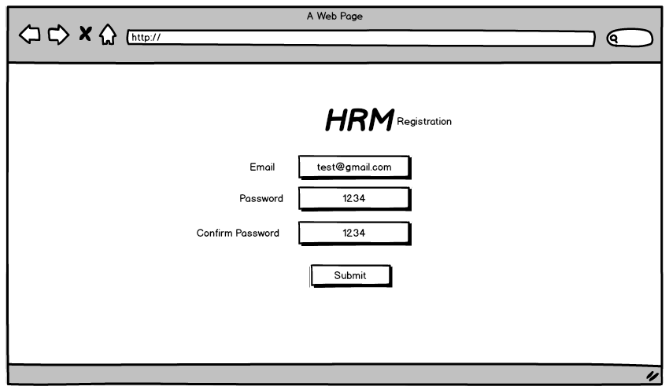

1. **Login :** This is login page. Here user input username and password to login HRMS.

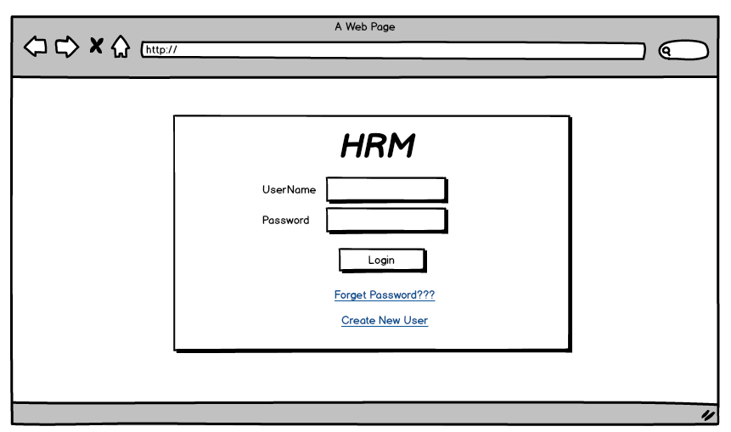

1. **Forget Password :** User can reset password if forgotten.

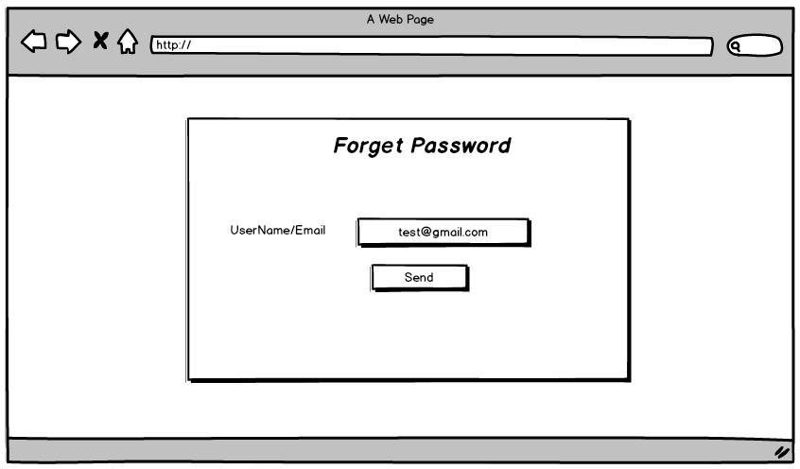

1. **Home :** After login this page will appear Home page Or Dashboard.

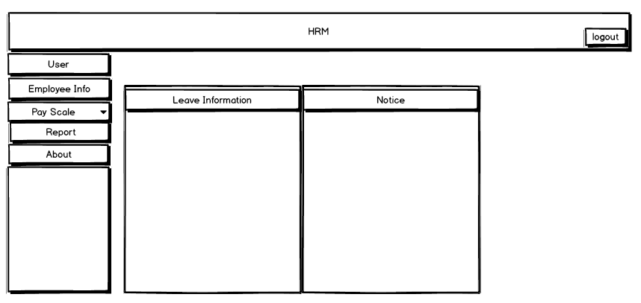

**User**

1. **Change Password :** This section will change user password.

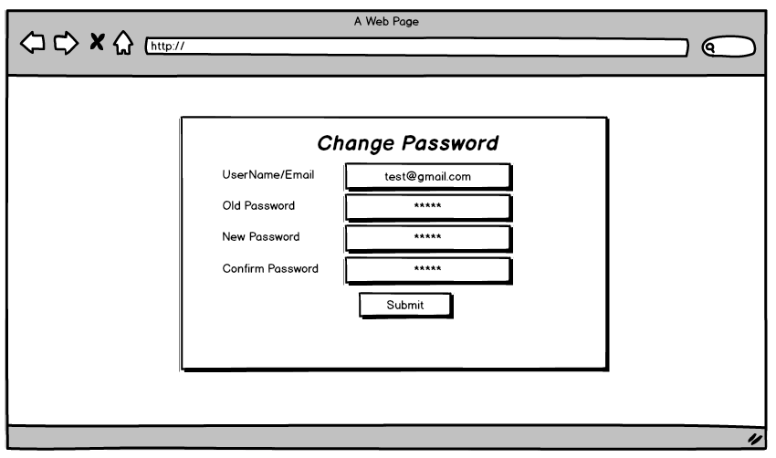

**Employee Information**

1. **Add Department :** This section will Department information.

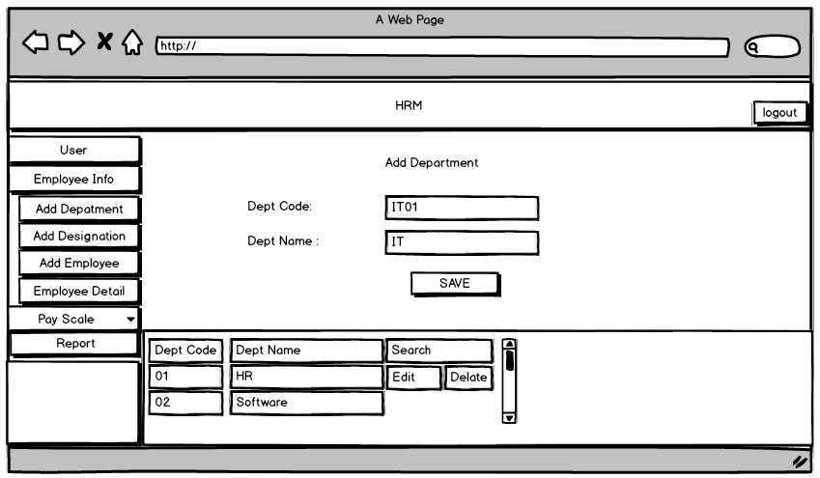

1. **Add Designation :** This section will add Designation information

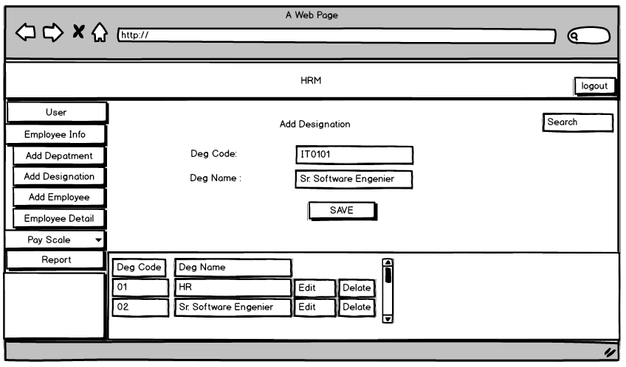

1. **Add Employee :** This section will add new employee information.

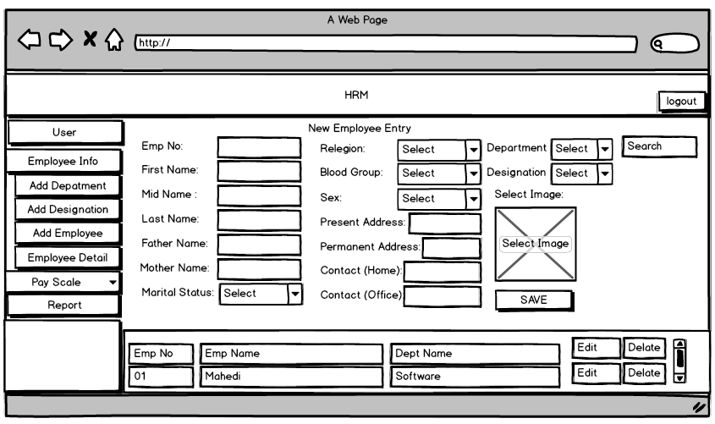

**Pay Scale**

1. **Salary Grade Setup :** This section will add new Employee salary Grade setup.

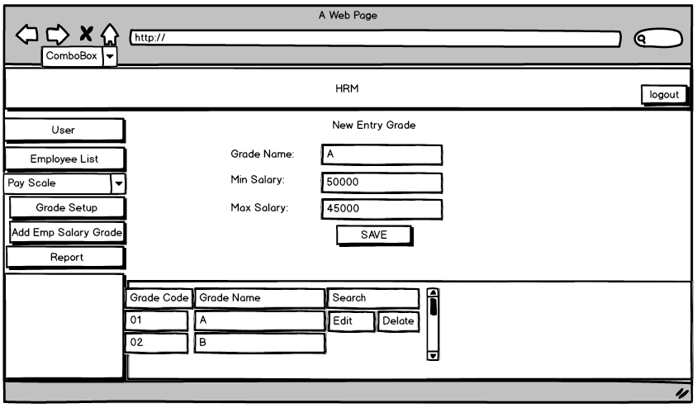

1. **Add Employee Salary :** This section will add Employee salary information.

